Name:

### Score: out of

# Manjimup SHS 2015

# Year 11 Mathematics Methods

# Test 8

# Optimisation, Integration, Rectilinear Motion

**28**

**Non-Calculator Section (No calculator nor notes, formula sheet is provided)**

**Time: 28 minutes Marks: 28 marks**

1. [1,2,1 = 4 marks]

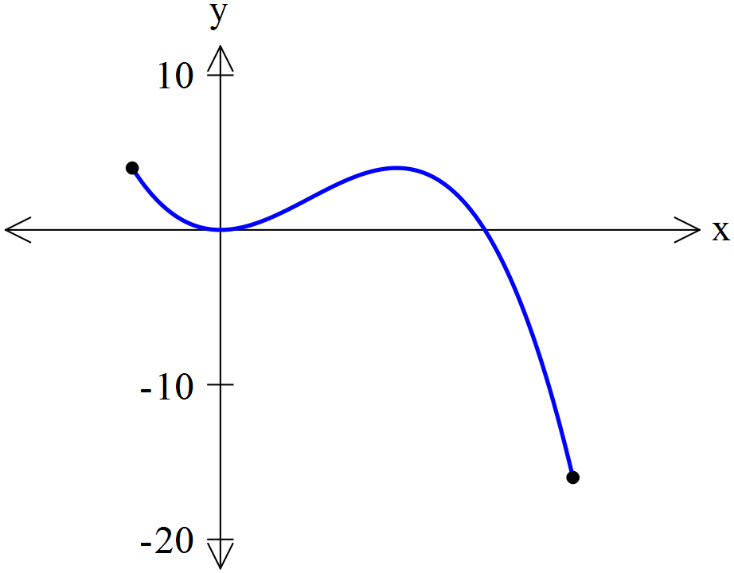

Consider the function f(x) = 3x2 – x3 over the

domain -1 ≤ x ≤ 4 sketched to the right

1. Find the derivative, 
2. Find the values of x where  = 0
3. Find the coordinates of the local maximum point.
4. [2,2,3 = 7 marks]

Find expressions for the following anti-derivatives.

1.  b)  c) 
2. [3 marks]

Find the rule for a curve that goes through (1,-1) with a gradient function of 

1. [2,2,1,2 = 7 marks]

An owner is exercising her dog. The velocity-time graph of the dog is shown is shown below.

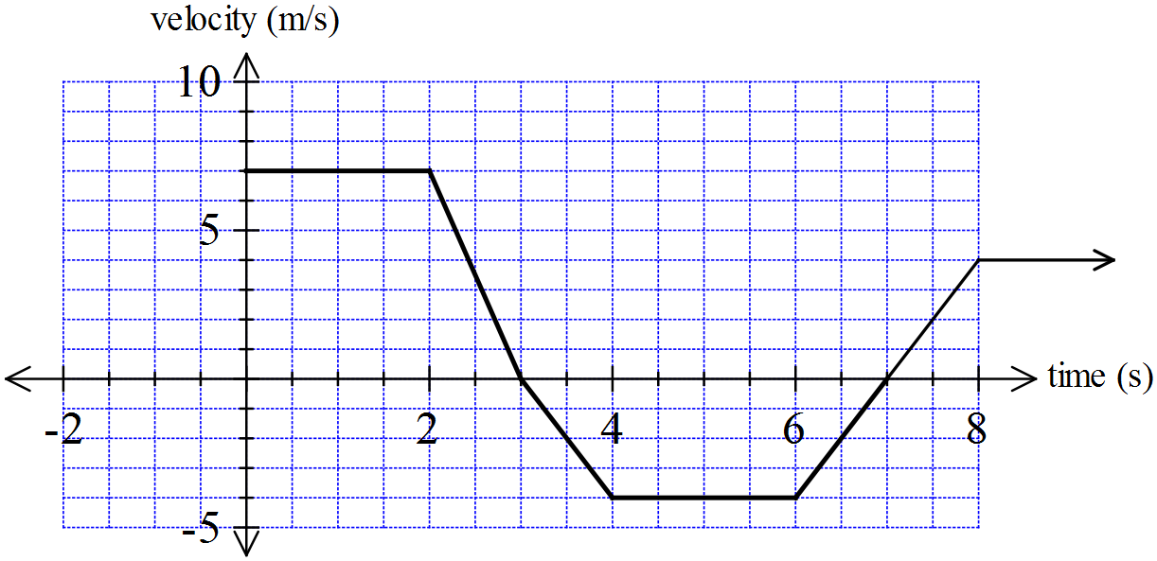

1. How far did the dog move in the first 3 seconds?
2. Describe the dog’s motion between 3 seconds and 8 seconds.
3. Find the dog’s acceleration when t = 7.
4. Find how far the dog was from its starting position at t = 7 seconds
5. [2,2,3 = 7 marks]

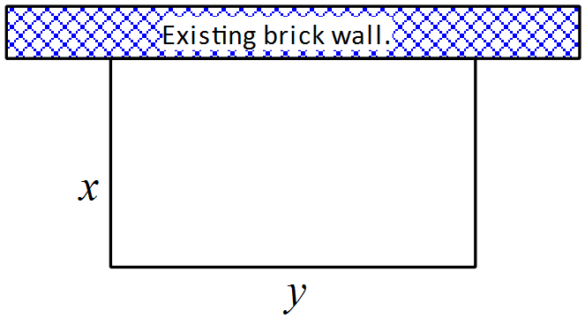

A person wants to fence off a rectangular enclosure for her

chooks. She has 22 metres of fencing but only needs three

sides of fencing as it will be located against a brick wall.

1. Find an expression for y in terms of x.
2. Find an expression for the area of the chooks enclosure, in terms of x only.
3. Using calculus find the maximum area of the chook enclosure and the value of x that gives this.

END OF SECTION ONE

# Manjimup SHS 2015

# Year 11 Mathematics Methods

# Test 8

# Optimisation, Integration, Rectilinear Motion

Name:

### Score: out of

**30**

**Calculator Section (Calculators and 1 page (A4) of notes permitted, formula is sheet provided)**

**Time: 30 minutes Marks: 30 marks**

6. [1,2,1,2,2 = 8 marks]

A wind-up toy car is designed so that when it is wound up; it moves forward for a certain distance, stops then reverses direction before coming to rest. It then does not move until wound up again.

It’s motion for this time is found from the rule x(t) = t3 – 12t2 + 36t; 0 ≤ t ≤ T where T is the time it stops for the final time in seconds and x is the displacement of the car in cm.

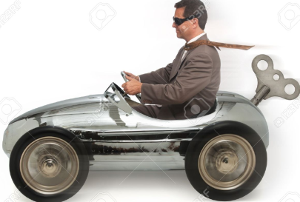

1. What is the displacement at t = 5?
2. Find the times when the car stops.
3. Determine the velocity of the car after 3 seconds.
4. Will the car have zero acceleration? If so, at what time?
5. Find the distance the car will travel.

7. [1,2,4 = 7 marks]

The number of bacteria in a student’s lunchbox, t minutes after being he puts his hand in is given by the rule:

B(t) = 4200 + 900t + 30t2 – t3 for 0 ≤ t ≤ 40.



1. How many bacteria were in the lunchbox after 6 minutes?
2. Find the rate of change of bacteria after 10 minutes.
3. Use methods of calculus to determine the maximum number of bacteria and when this occurred.

8. [2,2,3 = 7 marks]

A train departs a station at 9 am, with its velocity given by the rule v(t) = km/hour.

1. Determine the times when the train is stationary.
2. Find a rule for the displacement from the station, at any time t.
3. To the nearest minute, find when the train was 15 kilometres from the station.

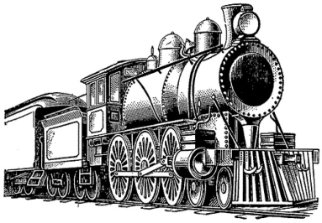

9. [2,2,4 = 8 marks]

A box is designed by a Year Eleven student to house their cool dude belly, nose and ear studs. It is to be open topped with the length five times the width. The volume of the box must be 400 cm3.



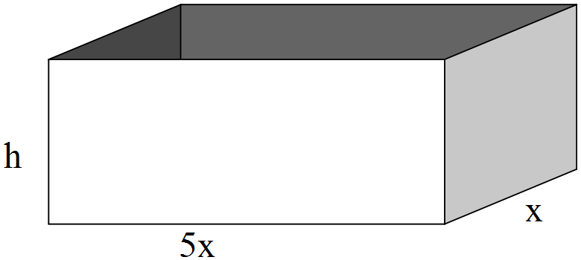

a) Show working to show that h = 

1. Show why the surface area of the box must be given by the rule A = 
2. Use your Casio and methods of calculus to find the dimensions of the box that will minimise the

surface area of the box. State the minimum surface area needed.

Give all answers to one decimal place.

END OF SECTION 2